**Terna Engineering College**

**Computer Engineering Department**

Program: Sem VII

[**Course: Artificial Intelligence & Soft Computing (AI&SC)**](https://github.com/Amey-Thakur/ARTIFICIAL-INTELLIGENCE-AND-SOFT-COMPUTING-AND-ARTIFICIAL-INTELLIGENCE-AND-SOFT-COMPUTING-LAB)

**Experiment No. 07**

**PART B**

**(PART B: TO BE COMPLETED BY STUDENTS)**

***(Students must submit the soft copy as per the following segments within two hours of the practical. The soft copy must be uploaded on the Blackboard or emailed to the concerned lab in charge faculties at the end of the practical in case there is no Blackboard access available)***

| Roll No. 50 | Name: AMEY THAKUR |
| --- | --- |
| Class: BE-COMPS-50 | Batch: B3 |
| Date of Experiment: 02-10-2021 | Date of Submission: 02-10-2021 |
| Grade : |  |

**Aim:** To Implement Fuzzy-Controller.

**B.1 Software Code written by a student:**

* Initialize with the command “fuzzy”



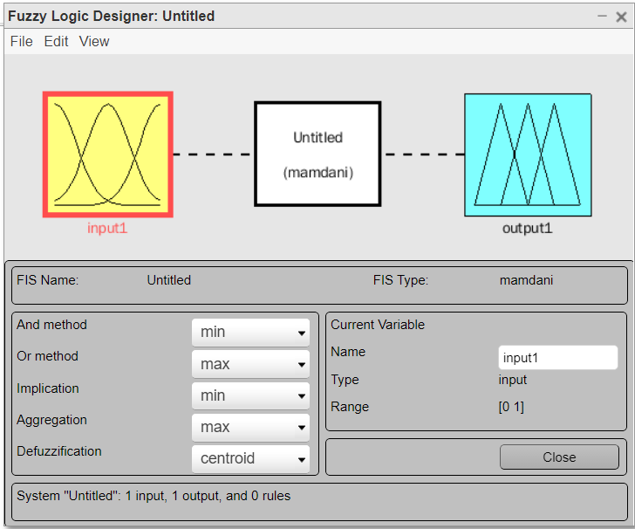

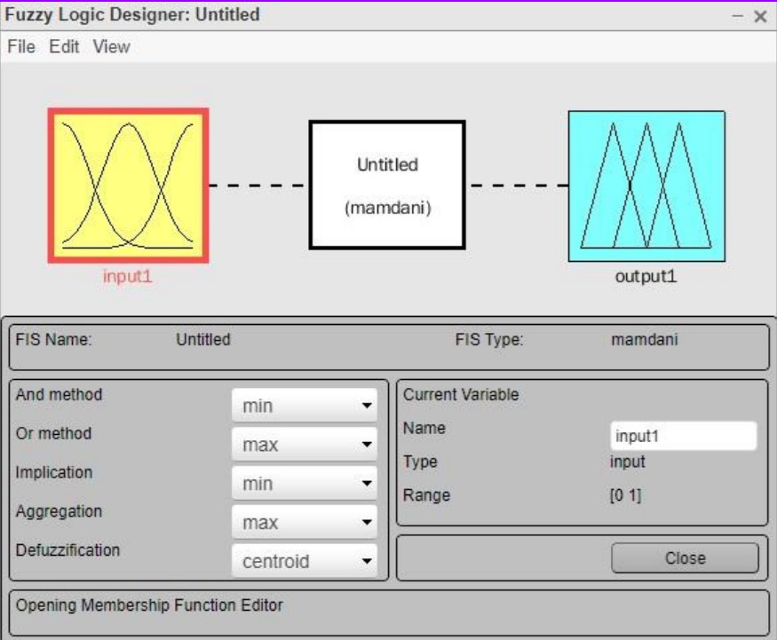

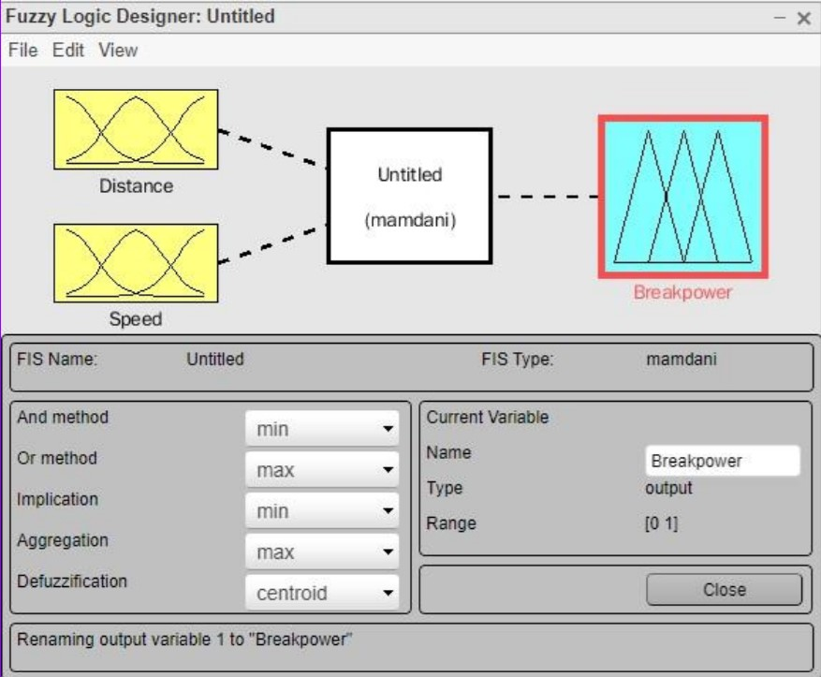

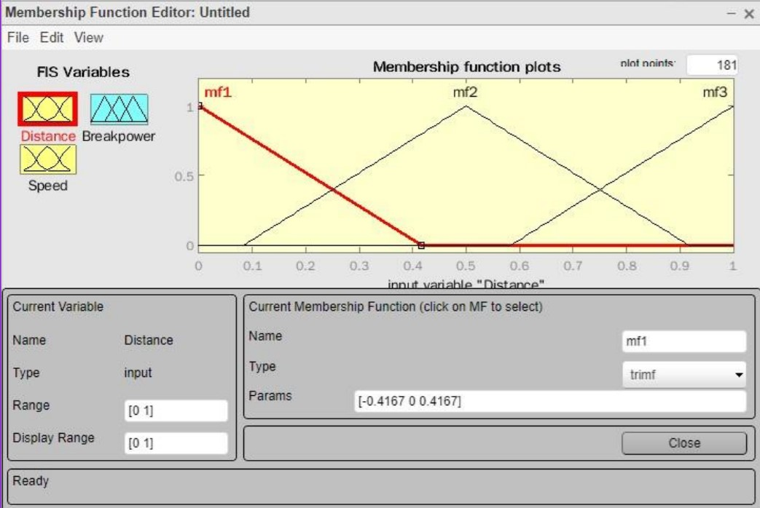





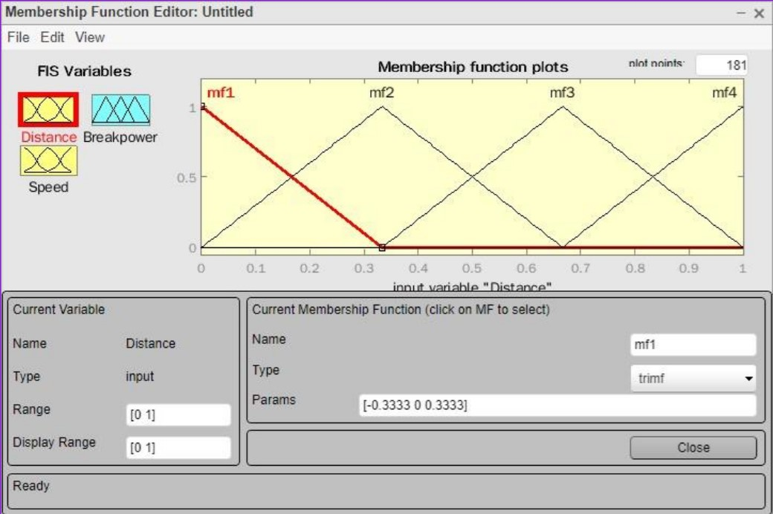

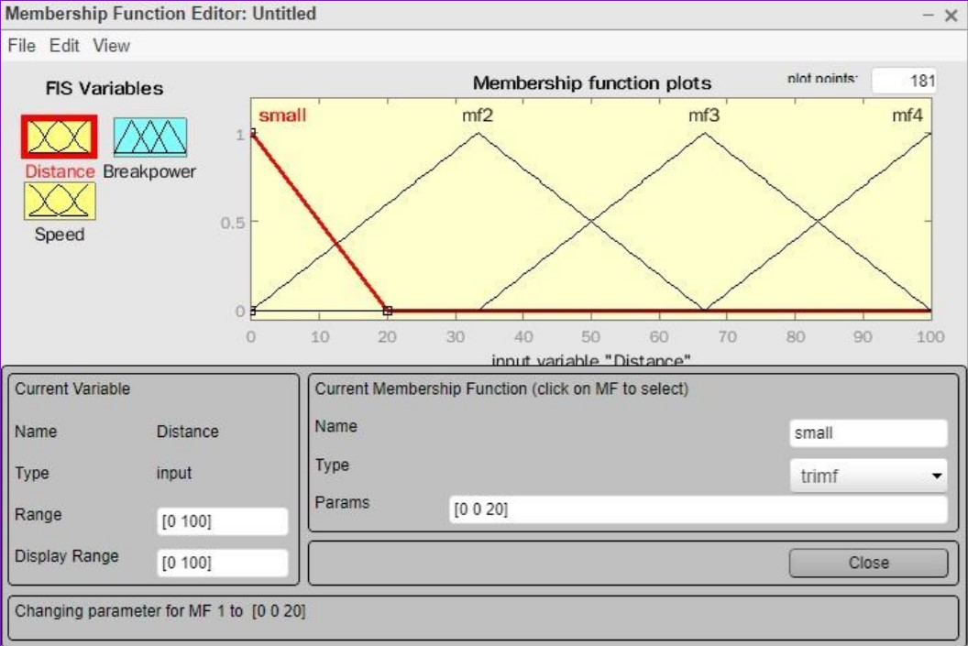

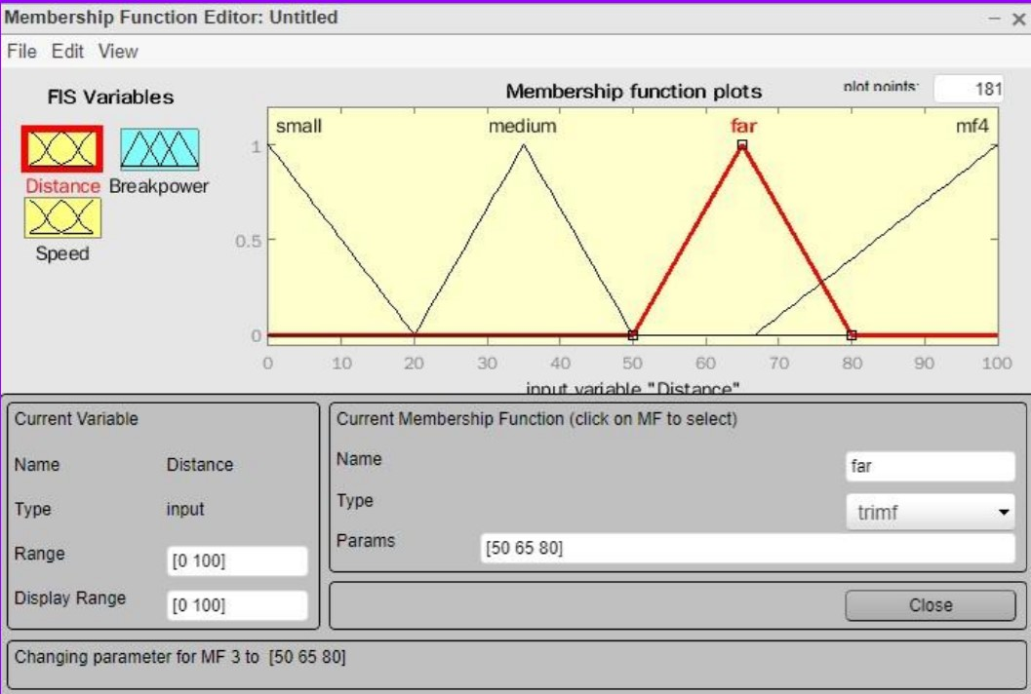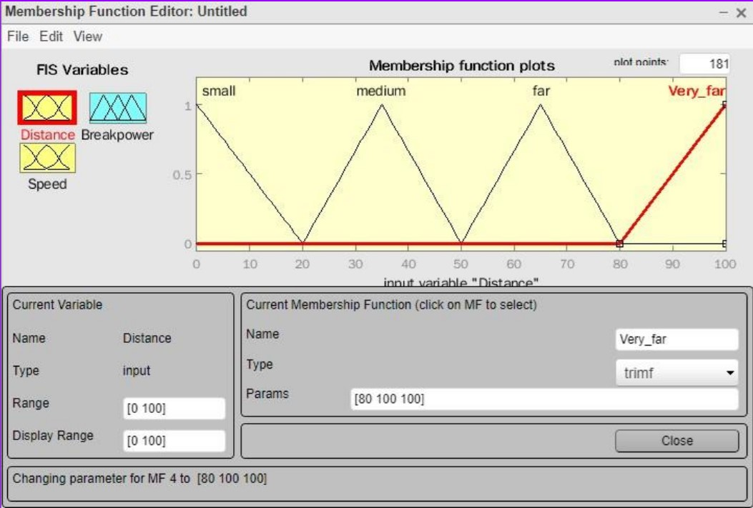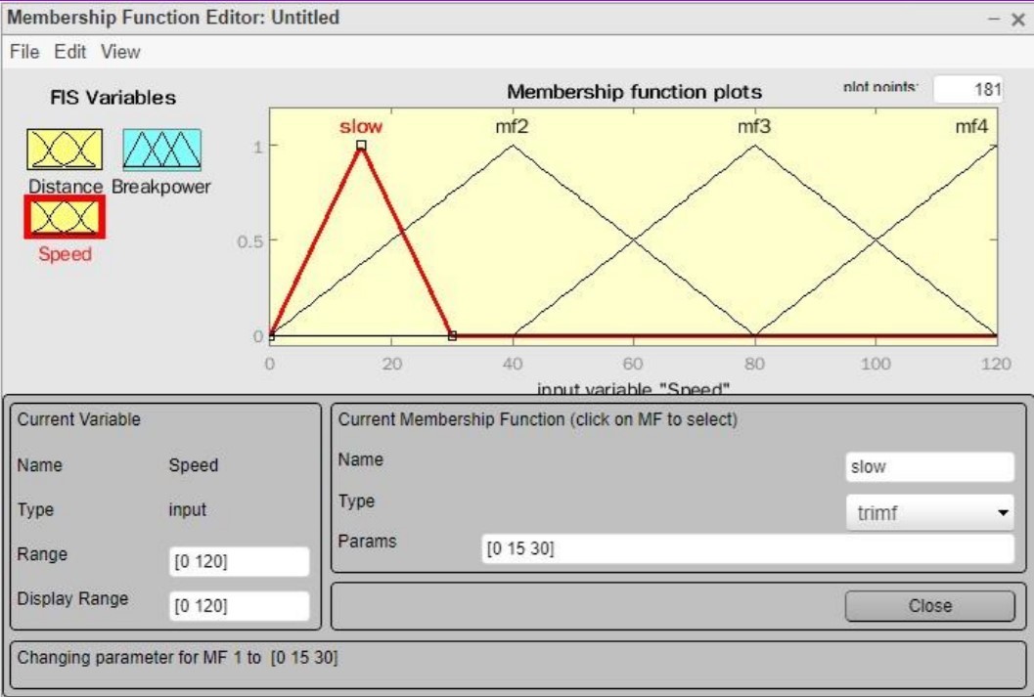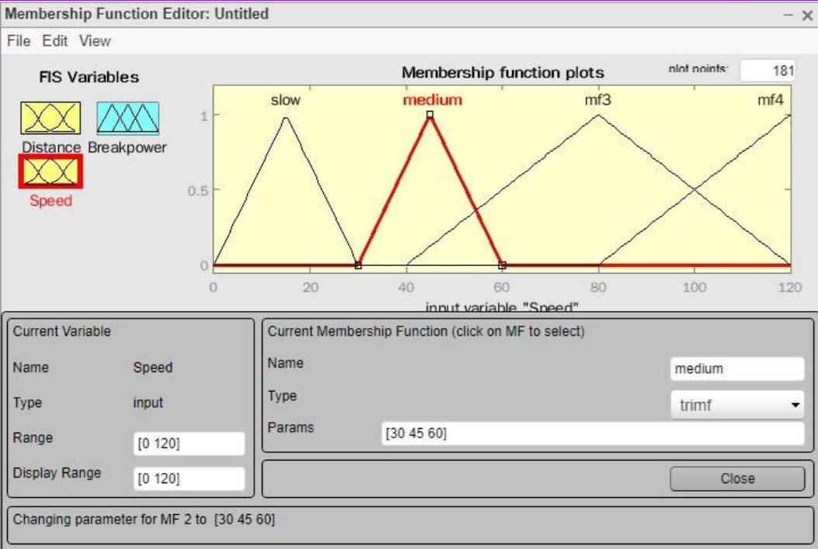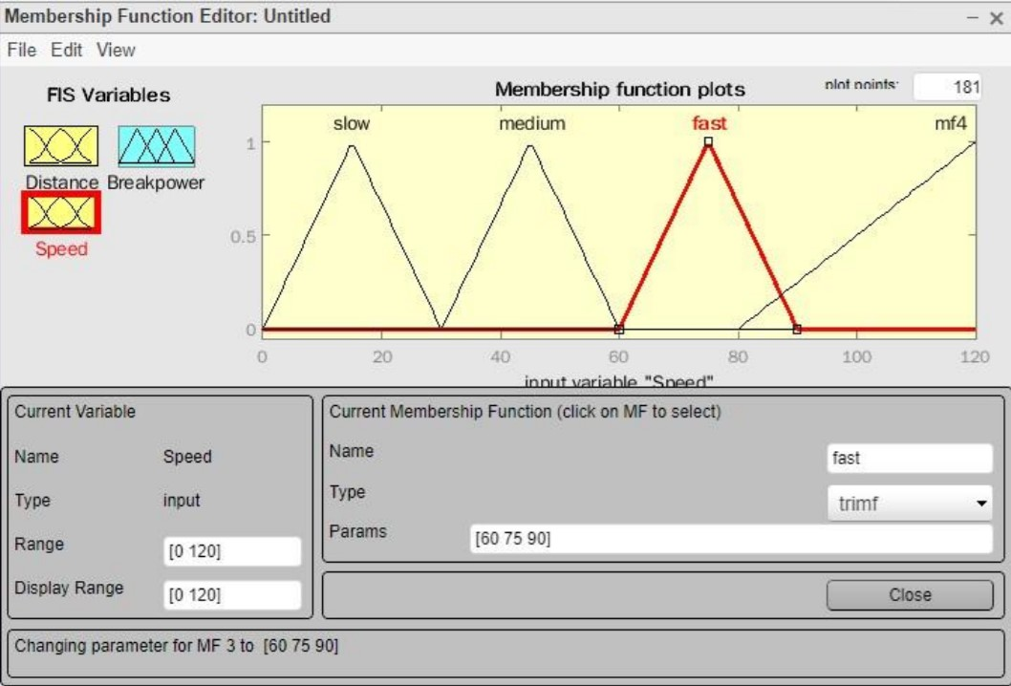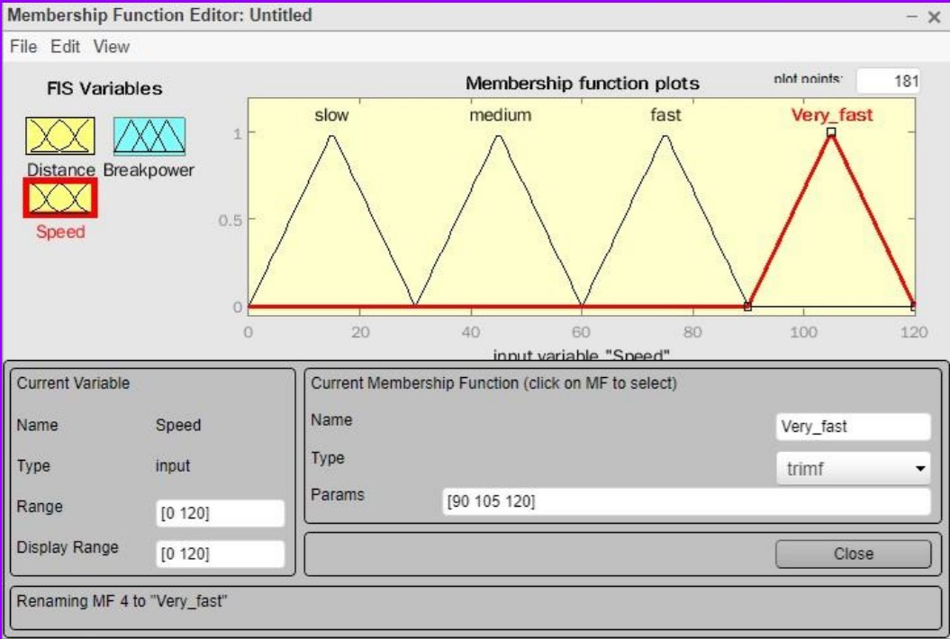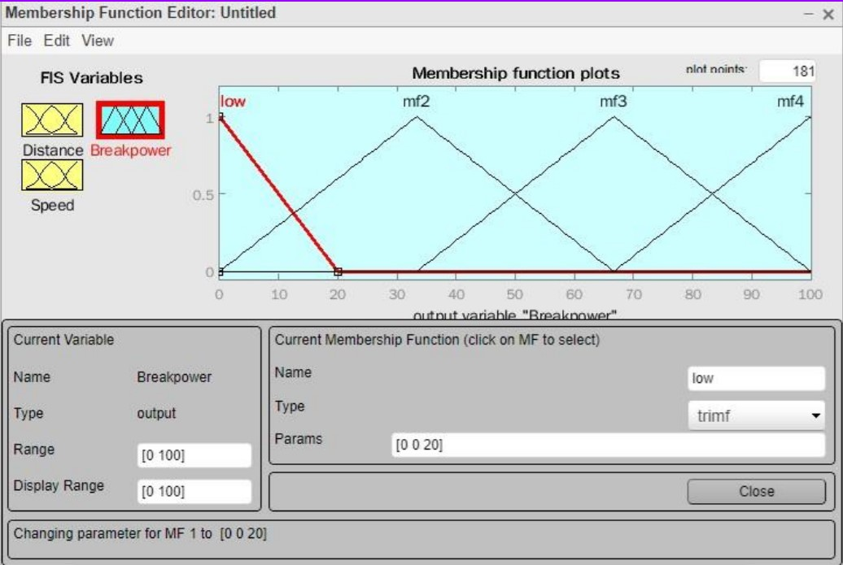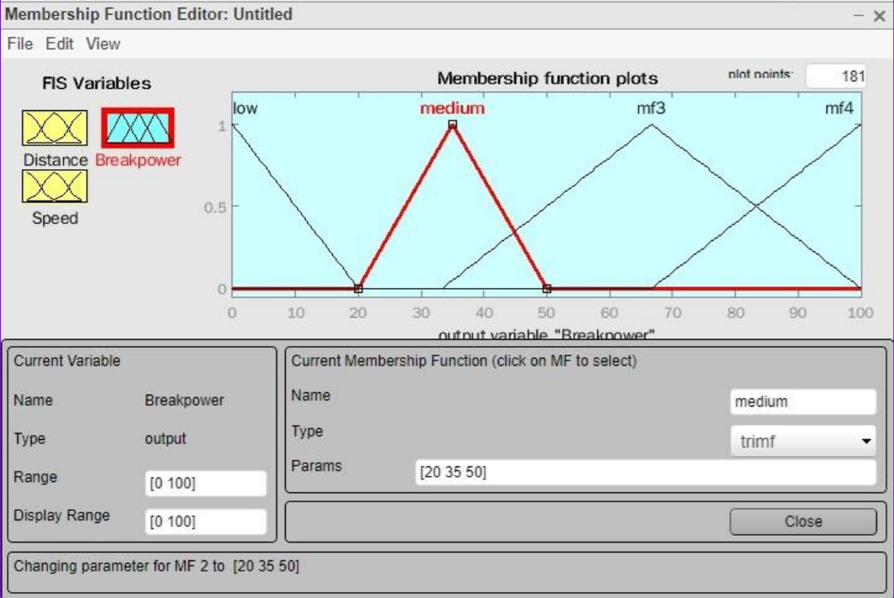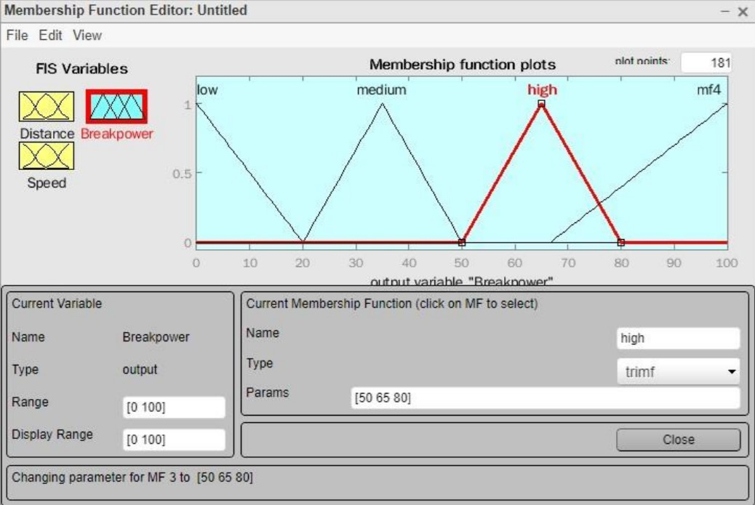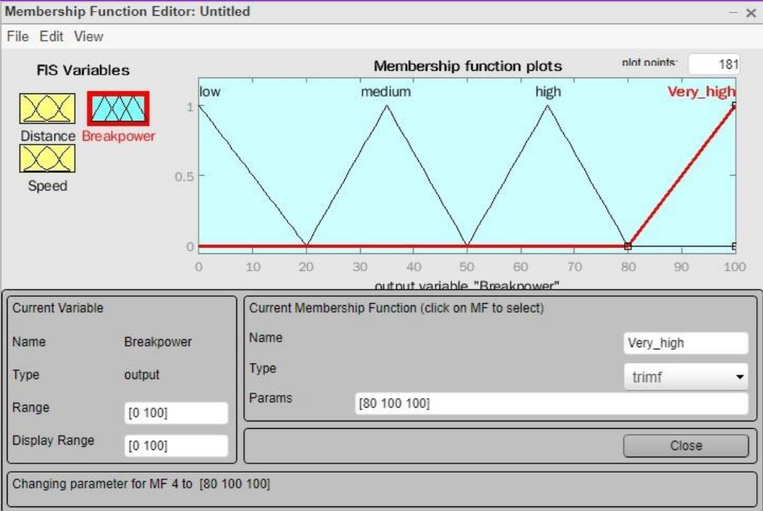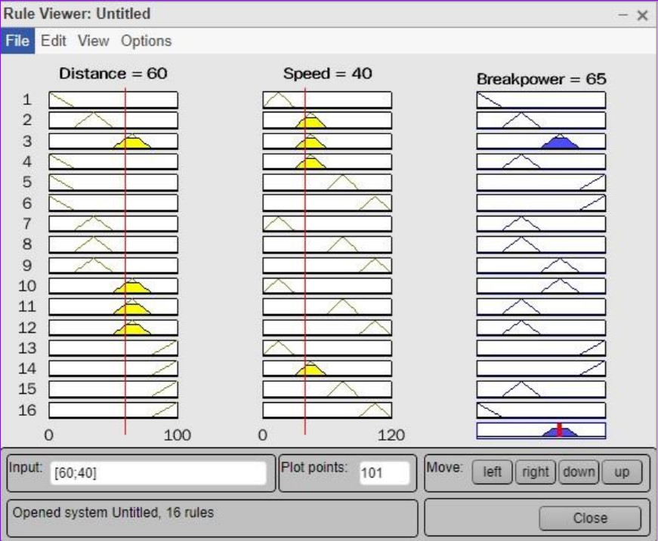

**B.3 Observations and learning:**

We utilized fuzzy logic concepts and heuristics based on the human experience. We generalized in order to provide acceptable rules for inference systems. In addition, we showed fuzzy inference systems.

**B.4 Conclusion:**

Hence, we were able to implement the Fuzzy Controller.

**B.5 Question of Curiosity**

**Q1)** What is the sequence of steps taken in designing a fuzzy logic machine?

**Ans:**

Following is the sequence for designing a fuzzy logic machine:

Fuzzification->Rule Evaluation->Defuzzification

When designing a fuzzy logic, we first have to define the fuzzy sets and make

appropriate member functions. The rule evaluation comes in which matches the sets to its corresponding rules.

**Q2)** What is the reason that logic function has rapidly become one of the most

successful technologies for developing sophisticated control systems?

**Ans:**

There are mainly two reasons:

1. Fuzzy logic applies the concept of ‘certain degree’ which is similar to the way human beings think. Instead of just being either true or false, fuzzy logic can be true partially and also false partially at the same time. This is similar to the human mind.
2. Fuzzy logic can uses exact points representing to what degree an event occurs and with fuzzy rules, it generates precise outcomes.